Final Mini Project – Code Explanation

Antz Claveus, Ethan Carter, Oscar Garcia, and Thomas Lilchin
Department of Engineering and Technology, Miami Dade College
COP 2800: Java Programming
Dr. Martins Idahosa
April 26, 2026

Welcome to our final Mini Project for this Java Programming course! Through this project, we exercised our skills in Object-Oriented Programming (OOP). The main OOP concepts that we went over were encapsulation, object creation and usage. Outside of OOP practices, we also utilized static classes and static members (in the form of the static class SmartDevice and the static member deviceCount).
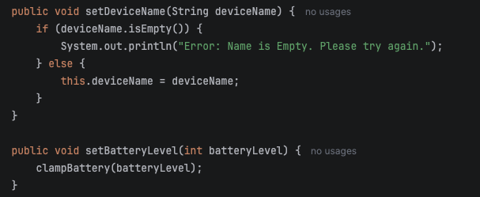
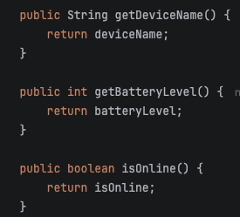
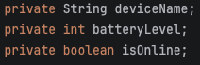
In terms of encapsulation, there is a few bits we would like to go over. Mainly, how encapsulation protects data. In general, encapsulation is the practice of “fencing off” data from outside interference. This is evident in our project. Our first few fields, deviceName, batteryLevel, and isOnline are all private (shown in the screenshot on the right). This is the metaphorical “fence” – by being private, only methods inside of the same class can access this data. To access this data from the outside (outside the static class), we need to use getters and setters. These are methods that do just that – get/retrieve the data stored in the private fields and set data to be stored in the private fields. Without these methods, it would be impossible to access the private fields because, as their access modifier states, it is private, or not accessible outside the class.
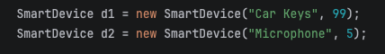
Now, let’s move on to objects. How can objects maintain independent states? This happens through memory creation and management. When objects are declared, separate spaces in memory are created for them. These separate spaces in memory allow for independent states.
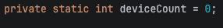
Finally let’s look at the difference between static members and instance members. The difference between the two is that static members “belong to the class itself rather than any individual object” (UPGrad, 2025). Additionally, this means that a static member is shared by all objects, rather than having one member for every object (Oracle, n.d.).

References
Vadapalli, P. (2026, April 21). Understanding static variable in Java. upGrad. https://www.upgrad.com/tutorials/software-engineering/java-tutorial/static-variable-in-java/
Understanding Class members (The JavaTM Tutorials > Learning the Java Language > Classes and Objects). (n.d.). https://docs.oracle.com/javase/tutorial/java/javaOO/classvars.html

